A location that holds a special meaning to me is the Philippines. The Philippines is where I grew up, which is my hometown. I made a lot of memories there and it really feels like home.

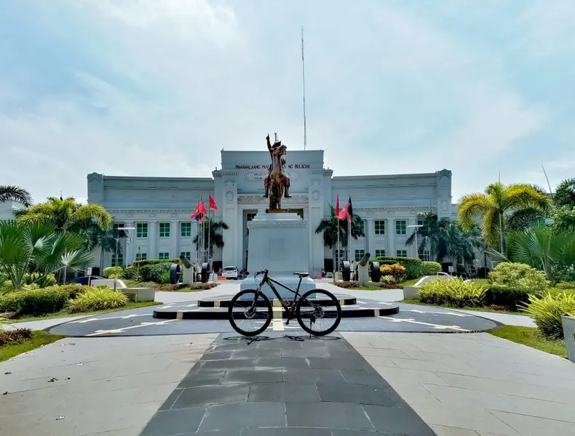

I'm usually at Dartmouth Commons in my free time. I like going there with my friends. We're usually always there because it's near and we spend a lot of quality time.



Kuwait was where I used to live for a while when I was younger. I liked it there because it was really peaceful. I also think it's pretty chill living there.

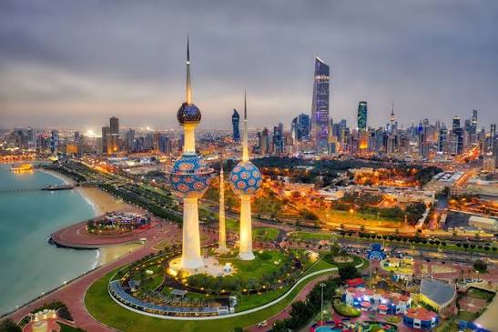

I really want to live in South Korea one day. I like their culture and I wanna study there. I also want to experience how they live there.

